**Lab Exercise 1**

**OpenMP Basics**

**Name:** Ayush Sharma

**Reg. No:** 15BCE1335

**Faculty:** Prof. Gayatri. R

**Note:**

**To execute OpenMP programs, Use:** gcc -fopenmp filename.c

1. **Basic Program to print “Hello World” using every available default number of threads.**

**Code:**

#include<stdio.h>

#include<omp.h>

int main(void)

{

#pragma omp parallel

printf("Hello world.\n");

return 0;

}

**Screenshot:**

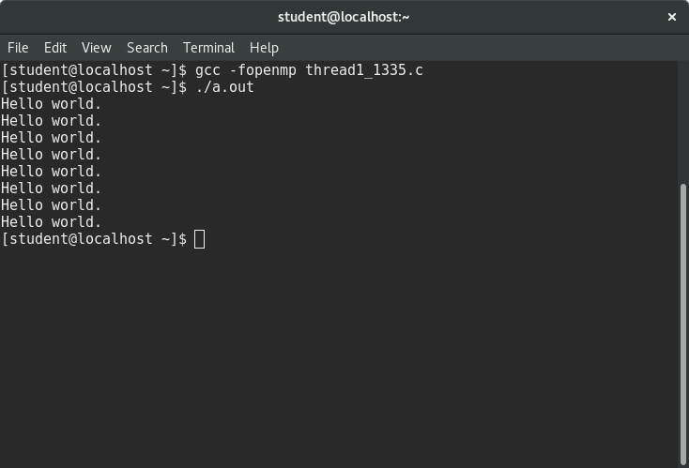

1. **Limiting number of threads**

**Code:**

int main(void)

{

#pragma omp parallel num_threads(3)

printf("Hello world.\n");

return 0;

}

**Screenshot:**

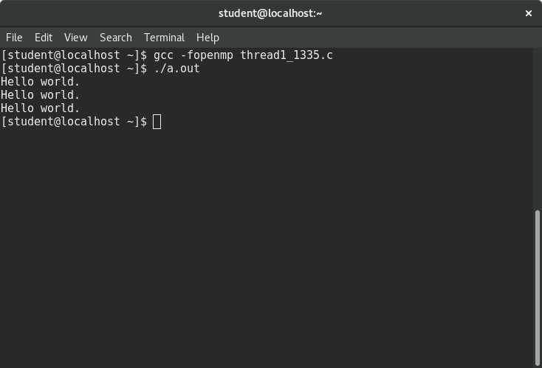

1. **Some processing using multiple threads.**

**Code:**

int main(int argc,char **argv)

{

int a[100000];

#pragma omp parallel for

for (int i=0;i<100000;i++)

{

a[i]=2*i;

}

return 0;

}

**Screenshot:  
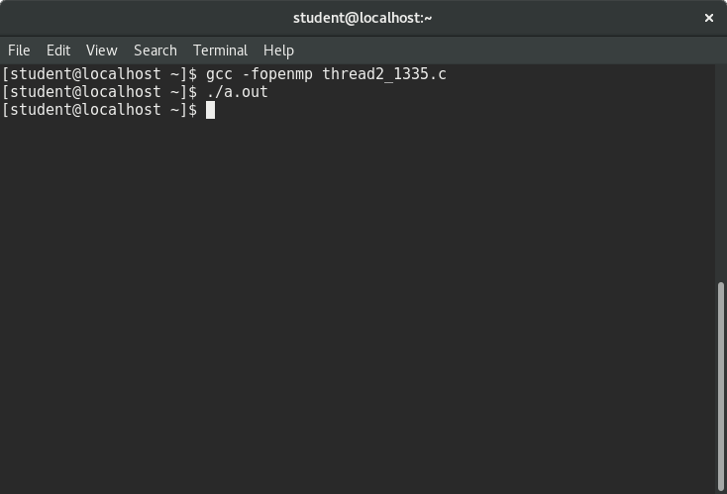**

1. **Checking thread rank for every thread.**

**Code:**

int main()

{

int omp_get_thread_num();

#pragma omp parallel

{

printf("Thread rank: %d\n", omp_get_thread_num());

}

return 0;

}

**Screenshot:**

